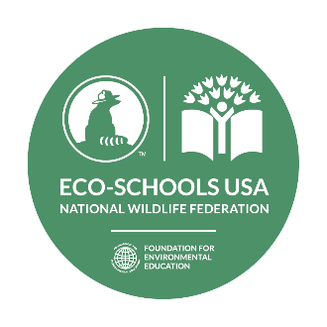

Guilford Elementary School Awarded Eco-Schools USA Green Flag
for Exceptional Achievement in Educating for Sustainability
Honor indicates commitment to sustainable management of school grounds, facilities and curriculum
Contact: Trish Lannon (Principal), Howard County Public School System, Guilford Elementary School, trish_lannon@hcpss.org, 410-880-5930
Columbia, Maryland (May 19, 2022) – Guilford Elementary School was recognized by National Wildlife Federation’s Eco-Schools USA program for exceptional achievement in educating for sustainability, improving the environmental footprint of the school grounds, facility and curriculum. It is the 8th school so honored in Maryland, and the 128th school in the USA to receive the prestigious Green Flag, the Eco-Schools highest honor. This is Guilford Elementary School’s 2nd Green Flag Award.
With more than 5,500 schools in all 50 states, the Eco-Schools USA program is based on the commitment and work of student-driven teams dedicated to issues such as reducing waste and consumption, climate resiliency, and environmental justice using audits, action plans, and other educational resources.
"National Wildlife Federation and Eco-Schools USA are proud of the example set by Guilford Elementary School in Maryland,” said Elizabeth Soper, Senior Director of K-12 Education Programs. “This award demonstrates not only a commitment to sustainability and environmental literacy for students and faculty, but as well, recognition by the school community that environment-based education supports and provides an effective approach to student learning and leadership.”
To receive the Green Flag, Guilford Elementary School students and faculty tackled a host of sustainability initiatives that began with forming an Eco-Action team; auditing environmental focus areas; and engaging and building community. These steps led to a certified NWF School Habitat, new planters for plants, Howard County Public Schools Winner for Baltimore Ravens Play 60 challenge by students having the most active minutes, and other green initiatives all designed to raise environmental awareness, connect students to the natural world, improve the school’s environmental footprint, and increase student engagement, while saving money for the school.
National Wildlife Federation was named the stateside host for the international Eco-Schools program in 2008. The International Eco-Schools program (http://www.ecoschools.global) is a network of over 56,000 K-12 schools in 70 nations, started in 1994 by the Foundation for Environmental Education (FEE) with support from the European Commission. It was named by the United Nations Environment Program (UNEP) as a model initiative for Education for Sustainable Development in 2003 and in 2016 were included as members of United Nationals Educational, Scientific, and Cultural Organization (UNESCO) and the Global Action Program (GAP).
Learn more about Eco-Schools USA, http://www.nwf.org/eco-schools-usa. Follow us on Facebook and Twitter.
The National Wildlife Federation is America’s largest conservation organization, uniting all Americans to ensure wildlife thrive in a rapidly changing world.

