Trish Lannon, Principal
LaRae Guide, Assistant Principal

May 19, 2023

DATES TO REMEMBER:

May 25th | Orchestra Spring Concert at 6:30pm
May 29th | Memorial Day- Schools and Offices Closed
June 2nd | Band Spring Concert at 6:30pm
June 5 - 9 | Mobile Science Lab - Parent Volunteers Needed
June 5th | Summer School Parent Orientation at 6pm
June 7th | Professional Work Day- Schools Close 3 Hours Early
June 8th | PTA Meeting at 6:30pm
June 9th | Last Day of PreK Classes
June 12th | Kindergarten Promotion Ceremony 9:30am  Schools Close 3 Hours Early
June 13th | 5th Grade Promotion Ceremony 9:30am  Schools Close 3 Hours Early
June 14th | School Spirit Day - Beach Day  Schools Close 3 Hours Early/Last Day of School

NEWS & INFORMATION
SURVEY 1
GES 2022-2023 Parent Involvement Input Survey
Dear Parents and Guardians,
As you may know, Guilford (GES) is a Schoolwide Title I School. Parent Involvement is an important part of Title I. GES and Howard County Public Schools (HCPSS) value your input and partnership in supporting the academic success of your child. Please take a few minutes to complete this survey regarding school improvement, climate, and family engagement. This will be used to evaluate our Title I program so that we can better serve you. Your responses will be kept strictly confidential. Please complete the online survey by 5/31/23.

Encuesta de Opinión de la GES sobre la Participación de Padres 2022-2023
Estimado Padre y Tutor:
La Escuela Primaria Guilford (GES, por su nombre en inglés) es una Escuela de Título I a lo Largo de la Escuela. La participación de padres es una parte importante de Título I. La GES y el Sistema de Escuelas Públicas del Condado de Howard (HCPSS, por su nombre en inglés) valoran su opinión y asociación en apoyo del éxito académico de su niño. Por favor, dedique algunos minutos para completar esta encuesta sobre la mejora escolar, clima y compromiso familiar. Esto será utilizado para evaluar nuestro programa de Título I para poder asistirlo de una manera mejor. Sus respuestas serán estrictamente confidenciales. Por favor, complete el cuestionario en línea antes del 31 de mayo de 2023.

SURVEY 2
TITLE 1 PARENT SURVEY
Howard County Public Schools Title I Office receives Title I funds to provide additional support and resources to Title I Schools. The Title I Office supports family engagement through the implementation of its Parent, Family, and Community Involvement Plan and by providing schools with funds to support family engagement. Please take a moment to complete the HCPSS Title I Parent, Family, and Community Involvement Input Survey, providing feedback on the district's Parent, Family, and Community Involvement Plan and parent involvement funds.

La Oficina de Título I de las Escuelas Públicas del Condado de Howard recibe fondos Título I para proveer apoyo y recursos adicionales a Escuelas Título I. La Oficina de Título I apoya el compromiso familiar mediante la implementación de su Plan departicipación de padres, familias yla comunidad y proporcionando a las escuelas con fondos para apoyar la participación familiar. Por favor, dedique un momento para completar la Encuesta de opinión sobre participación de padres, la familia y la comunidad del HCPSS, realizandocomentarios sobre el Plan de participaciónde padres,familias y la comunidad y los fondos para la participación de padres del distrito.

Thank you and have a great day!

MOBILE SCIENCE LAB - VOLUNTEERS NEEDED
The Food, Fiber & You Mobile Science Lab from the Maryland Agricultural Education Foundation (MAEF) will be at our school June 5 - 9. All students in K-5 will participate, and our PreK students will get to take a tour of the lab.

A teacher from the Foundation will be running the lab lessons and the classroom teacher will remain with the class, but we also need to have a parent/grandparent volunteer to assist. Please consider signing up to volunteer! You can view the lab schedule HERE to help you decide what time you would like to sign up for. Use the link below to sign up. If you have any questions, please email Mrs. Shaughnessy at stephanie_shaughnessy@hcpss.org and she can assist you.

https://www.signupgenius.com/go/10c0b4bada623a3fe3-science#/

Special Education Parent Involvement Survey
Special Education Parent Involvement Survey: All Parents of students with disabilities were sent the Maryland Special Education Parent Involvement Survey. The purpose of this survey is to hear from parents about how well they think their child’s school is partnering with them and promoting parent involvement in their child’s education. This information will provide valuable feedback for the HCPSS Department of Special Education. The last day to complete the survey is May 19. The survey can be accessed online: (https://www.mdparentsurvey.com)

Kindergarten Alphabet Countdown
Can you believe that the end of kindergarten is almost near? Soon we will begin our kindergarten alphabet countdown to the end of the school year.
Each day we will engage in an activity that corresponds to a letter of the alphabet. Please check the calendar daily and help your child come to school ready to celebrate the end of the school year in alphabet style! Some days activities will occur in class or will be provided by the teacher and some days students may need to dress accordingly or bring something in, please refer to the calendar below!
Thanks so much - The Kindergarten Team

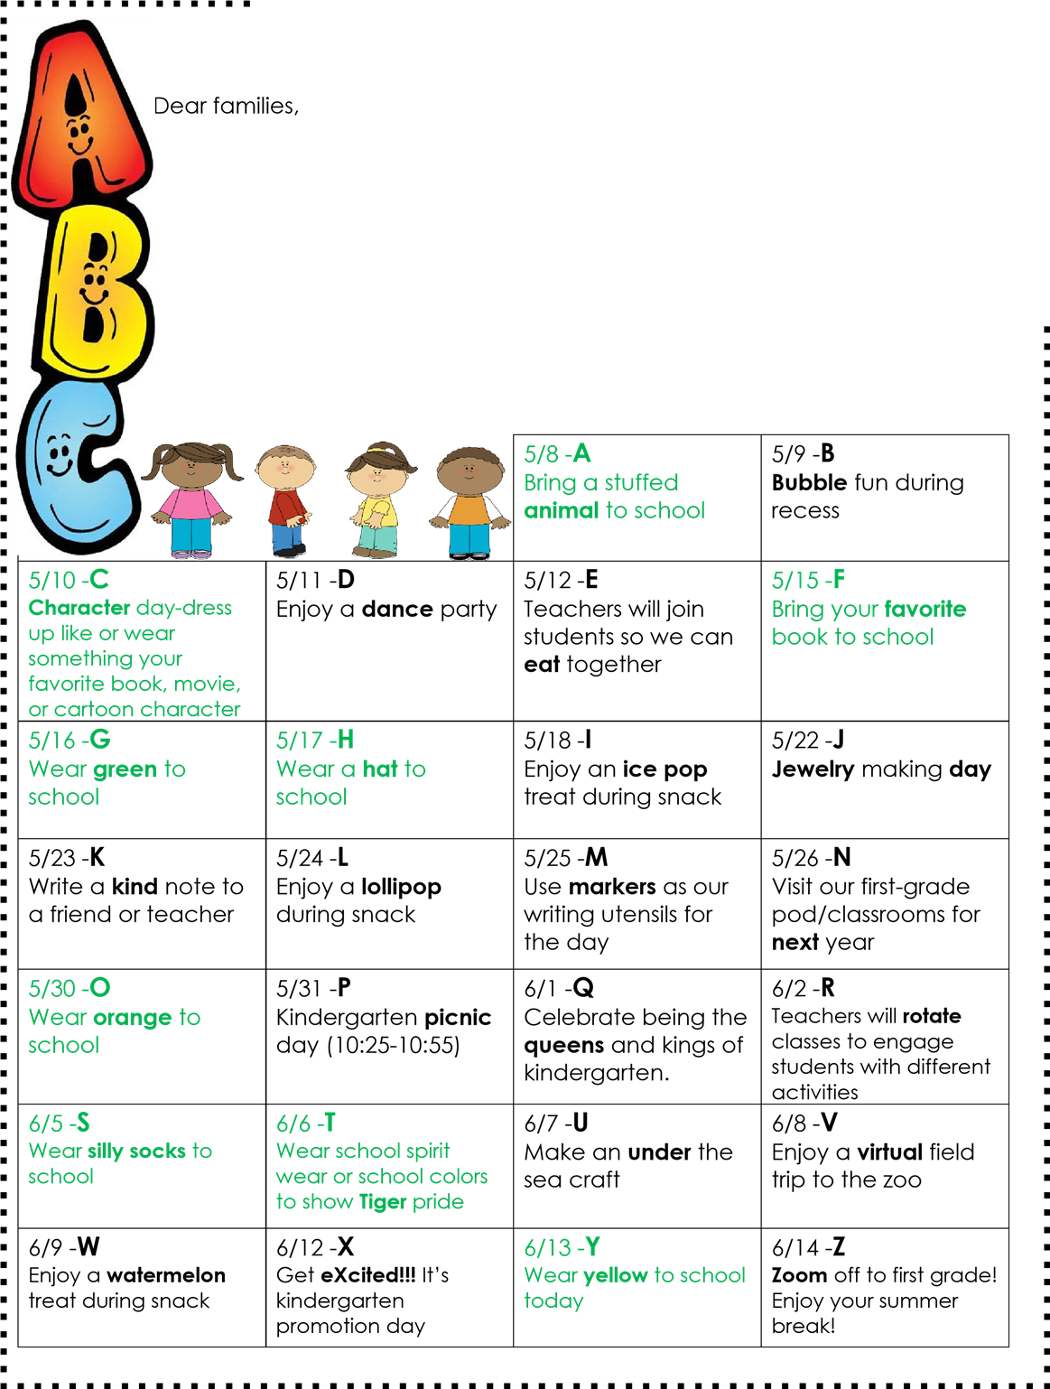

IMPORTANT REMINDER: REGISTER BY JUNE 1st FOR 23/24 BUS SERVICE
Families whose students are eligible for HCPSS-provided transportation are required to register by 6/1/23 to receive bus service for the coming 2023-2024 school year. Families who reside in non-transportation areas and those who have students who receive transportation as part of their Individualized Education Program (IEP) or 504 Plan do not need to take any action.

TITLE 1 PARENT SURVEY
Howard County Public Schools Title I Office receives Title I funds to provide additional support and resources to Title I Schools. The Title I Office supports family engagement through the implementation of its Parent, Family, and Community Involvement Plan and by providing schools with funds to support family engagement. Please take a moment to complete the HCPSS Title I Parent, Family, and Community Involvement Input Survey, providing feedback on the district's Parent, Family, and Community Involvement Plan and parent involvement funds.

La Oficina de Título I de las Escuelas Públicas del Condado de Howard recibe fondos Título I para proveer apoyo y recursos adicionales a Escuelas Título I. La Oficina de Título I apoya el compromiso familiar mediante la implementación de su Plan departicipación de padres, familias yla comunidad y proporcionando a las escuelas con fondos para apoyar la participación familiar. Por favor, dedique un momento para completar la Encuesta de opinión sobre participación de padres, la familia y la comunidad del HCPSS, realizandocomentarios sobre el Plan de participaciónde padres,familias yla comunidad y los fondos para la participación de padres del distrito.

IEES PARENT SURVEY
As part of our school improvement process, we are asking families to provide input about their equity priorities at our school. Please use the links below to complete the HCPSS Indicators of Educational Equity Survey by May 12th. We will use your input, along with other school data, to refine our school improvement plan for next year. Your voice is important for the process of school improvement and we truly hope every family will complete this survey.

This survey is anonymous and available in multiple languages. If you have children at more than one school, please complete one survey per school.
- English survey
- Spanish survey
- Chinese survey
- Chin survey
- Korean survey

UPDATES FOR THE 23/24 SY RELATED TO TRANSPORTATION AND SCHOOL START TIMES
Please take a moment to read up on the current updates from HCPSS. There will be more updates coming this week concerning transportation changes for next school year including the expansion of walking areas. To read the current updates, please go HERE.

DONATIONS FOR COFFEE & TEA IN STAFF LOUNGE
We are completely out of teas, creamer and cups. You can help out by either donating or by sharing our Wish List link with other family and friends on your social media. You can donate by using this link: Amazon Wish List.

FOOD PANTRY INFO

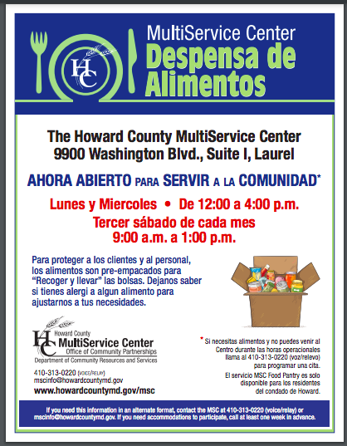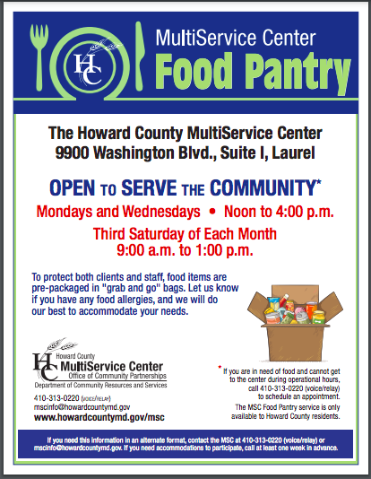

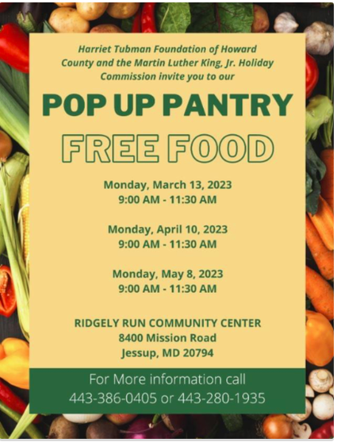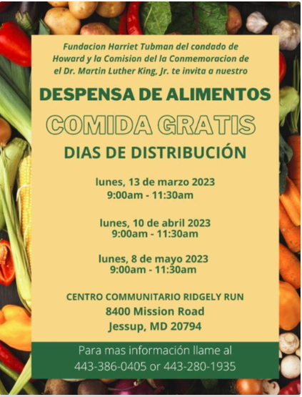

INFORMATION WORTH REPEATING

CLOTHING TO CASH FUNDRAISER
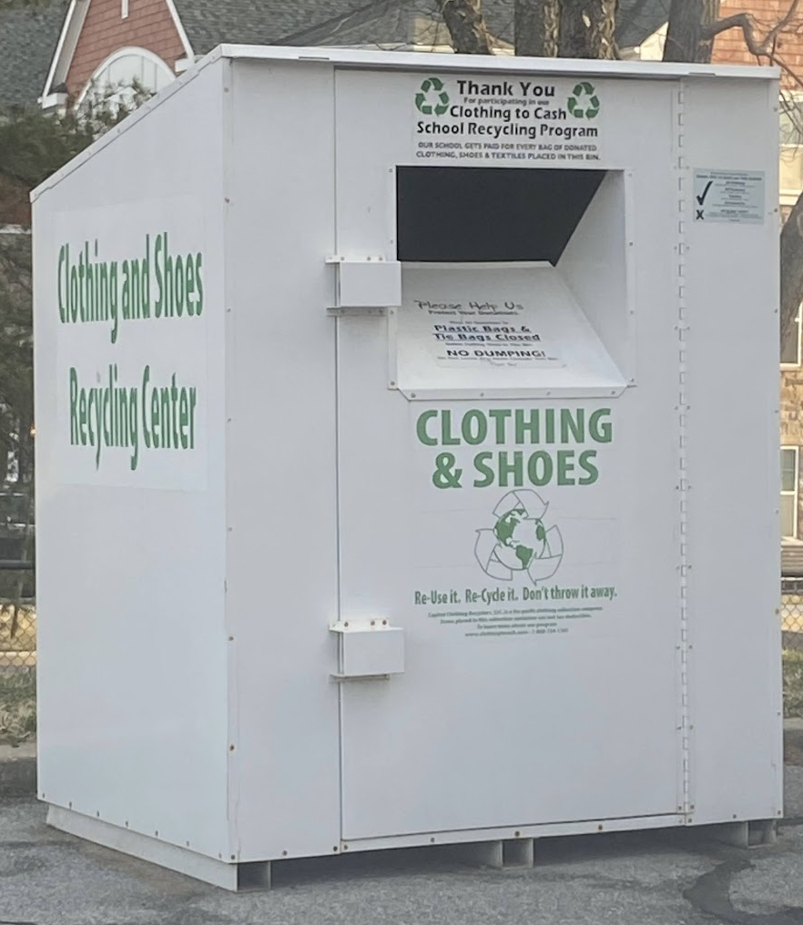
We have been participating in the Clothing to Cash Recycling Program that helps our school raise money that we hope to use to bring wonderful assemblies to our students. The collection bin is in the side parking lot near the dumpsters. We accept new and used clothing, shoes, sneakers, towels, and textiles. We want items in ALL conditions unwanted, outgrown, and out of style.
All items must be in a plastic bag and tied shut. Collections will be Reworn, Repurposed or Recycled. Save our landfills and give your items a second life. Help support our school and save the environment one bag at a time!
If you have any clothing, shoes, towels or textiles you no longer need, please drop them off in our collection bin. Your donations are turned into cash for our students.
CAREAPP
The CAREAPP website connects our community to free and reduced-cost services for food, health, housing, transportation, and more in multiple languages. Families can search by typing in the family’s zip code and identify relevant resources. This resource is brought to you by: https://www.howardcountymd.gov/departments/health

IMPORTANT NOTICE FOR THOSE WITH MEDICAL ASSISTANCE
Due to the Covid 19 pandemic, MA has been automatically renewed since March 2020. Automatic renewals will stop as of April 30, 2023. Please call the Health Department Insurance Line at 410-313-5845 to check your status. They will set up an appointment for you if needed.

ABSENCES
Reasons for an excused absence are the following: Illness of the student (please provide a note stating that your child was ill); death in the immediate family; state of emergency as declared by the governor; observance of a religious holiday. Notes for excused absences can be sent via email to your child’s teacher; to GESabsence@hcpss.org or on a piece of paper.

Parents/guardians are provided with 3 ‘discretionary’ absence days to use as needed during the school year to excuse a child’s absence. Please GO HERE to find the form to complete for a discretionary or religious absence request.

LATE ARRIVALS
Students must be in school prior to 9:25am to be considered on time. If they are late, an adult is required to come in the building and sign them in. We need to ensure that all attendance is accurate, and if you do not sign your child in late, they could be marked absent. We also need to ensure that all students are safe, so having an adult escort them in the building is necessary.
EARLY DISMISSAL
When you need to pick your child up early from school, please come into the school and someone in the front office will get your child for you. You will need to sign them out while you are waiting for them. Do not call ahead and request that your child be pulled out of class prior to your arrival. You must come into the building and sign them out first. Please remember that after 3:40pm, we will not be able to get students for early dismissal because they are in transitions for the end of the day. If you need them for early dismissal, please pick them up prior to 3:40pm.
PETS ON SCHOOL PROPERTY REMINDER
Families, please remember that the HCPSS policy is that pets are not allowed on school property when students are present. There is a returned increase of people walking dogs on campus when dropping off and picking up children.
Circular NO. 19 FY23 Animals on School System Property
Thank you in advance for your support and cooperation.

2023 SUMMER PROGRAMS PREVIEW AVAILABLE ONLINE
Families can now view the 2023 Summer Programs Preview, which includes descriptions of HCPSS’ four summer programs and enrollment information. Online enrollment requests for current HCPSS students will open Wednesday, February 1, at 6pm for the following programs:
- BSAP Summer Institute (Entering Grades K-9)
- Gifted and Talented Summer Institutes for Talent Development (Entering Grades 1-8)
- Innovative Pathways High School (Entering Grade 9 and Current Grades 9-12) - Math and Science courses only
- Summer Math Scholars Program (Current Grades 6-8)

NOTE: Invitations for eligible HCPSS students for Academic Intervention and Extended School Year Special Education programs will come directly from the school or special education team during Spring 2023. GUilford ES will once again be hosting this program at our school. For more info on this you can contact LaRae Guide at larae_guide@hcpss.org

Contact the individual program offices with additional questions.
- BSAP Summer Institute (SummerInstitute@hcpss.org)
- G/T Summer Institutes for Talent Development (GTSummer@hcpss.org)
- Innovative Pathways High School (IPSummer@hcpss.org)
- Summer Math Scholars Program (Summer@LTYC.net)

KIDS ON CAMPUS SUMMER PROGRAMS
Classes run June 26 - August 17, 2003. Registration opened January 26, 2003. Please go HERE to see what they offer.

HARRIS TEETER’S TOGETHER IN LEARNING
Harris Teeter’s Together In Education program gives schools a chance to earn funds when you link your VIC card and shop Harris Teeter brands.Money that our school earns will help fund student activities throughout the school year. So please consider linking your Harris Teeter card to Guilford Elementary School this year! Please go HERE to sign up for the program!

PARENT VOLUNTEERS
We are so excited that we can utilize parent volunteers this school year! Please reach out to your child’s teacher to set up any volunteering opportunity you may wish to take.
Please print and sign the certificate of completion for both trainings and bring them with you to school. We will keep track of everyone who has completed them. Please note that you must take this training each school year.
- Confidentiality certificate of completion
- Child abuse certificate of completion
All visitors must check in at the front office upon arrival.

SCHEDULES
Please use the links below to view the master schedule for this school year and the color rotation schedule for related arts. Your child’s teacher will be able to tell you what color day is associated with what related arts class. This will help when making sure your child wears sneakers on PE day and that they are dressed appropriately for art class.
- Master Academic Schedule
- 22/23 Color Rotation Schedule for Related Arts

OMHS FOOD PANTRY
The OMHS Food Pantry is open the last Wednesday of the month unless otherwise noted, from 3:00 - 5:00pm. You will need to bring a photo ID. Please do not arrive prior to 2:30pm to allow for student dismissal. Also, please remain in your car and a volunteer will come to your vehicle. More info can be found at the link below:
https://omhs.hcpss.org/student-services/food-pantry

The Food Pantry will be open on the following dates:
- March 29, 2023
- April 26, 2023
- May 31, 2023
- June 23, 2023
- July 26, 2023

THE ESSENCE OF US WORKSHOP SERIES
The Council of Elders of the Black Community of Howard County and the HCPSS Office of Diversity, Equity and Inclusion have partnered to present The Essence of Us: Chronicling the African American Experience, a workshop series geared toward middle and high school students that will provide a better understanding of African American history and how it is written. Workshops will be held both virtually and in-person from 10-11 a.m. on April 15 and May 13.

SCHOOL LUNCHES & FARMs INFORMATION
Families are reminded that the federal government has NOT extended waivers allowing free meals for all students. Consequently, for the 2022-2023 school year, students whose families do not qualify for free or reduced lunch will be required to pay the daily meal price.
- GES will have a free breakfast for every child, every day this school year
- Student Lunch - $2.80

Many HCPSS families are eligible to participate in the Free and Reduced Price Meals (FARMs) program, which provides children with a wide range of benefits including free or discounted college tuition, testing and application fees, academic and athletic program fees and many others in addition to free or discounted meals.

Families are urged to check their eligibility and complete a FARMs application as soon as possible. Families must submit a new application every school year.
Details on the Free and Reduced Meals program are available online. Use the link below to apply.

FARMs Online Application Link
https://www.myschoolapps.com/Application

Please contact the front office if you have any questions or need assistance with applying for the Free and Reduced Meal Program.

STUDENT & PARENT HCPSS HANDBOOK
The Student & Parent Handbook can be found online and it outlines the districtwide practices and policies related to parents and students, including the Student Code of Conduct, which students will be taught about over the first 2 weeks of school.

During our Back to0 School Nights, we will be highlighting the Student Code of Conduct, as well as our PBIS and 123 Magic programs so that parents/guardians are informed about behavioral expectations, the procedures we follow and how they can work with us to help ensure that we do not have any behavioral issues this school year.

NEW SCHOOL START TIMES FOR THE 23/24 SCHOOL YEAR
During its Feb. 23 meeting, the Howard County Board of Education adjusted the start times of schools for the 2023-2024 school year. There is no impact on the current school year. All changes will take effect in August.

The exact start time for each school will be determined this spring and shared with the community as transportation routes are finalized. However, Guilford ES is part of Tier 3, which means our school start time will be approximately 9:15am next school year. If your child will attend a different school next year, the start times for all schools can be found on the HCPSS website.

I want to reiterate words that HCPSS Superintendent Dr. Michael Martirano shared: “finalizing and fully implementing this plan will be a months-long process.” Much more information will be provided to students, staff and families from HCPSS and our school throughout that process. I encourage you to read more about the process to evaluate school start times on the HCPSS website.

I know you may have questions; however, please note that there are many impacted pieces as a result of this decision and all details will not be available right away. We are working with HCPSS central office staff on the logistics related to the implementation, and additional information will be provided to you as it becomes available.

TITLE 1 INFORMATION
TITLE 1 PARENTS RIGHT TO KNOW
The Federal Every Student Succeeds Act (ESSA) contains several provisions which promote a parent/school partnership through communication. One such provision gives parents of students attending Title I schools the right to ask for and receive information about the professional qualifications of their child’s classroom teacher, paraprofessional, and/or long-term substitute teacher. Below are links to a letter from the Superintendent explaining your rights.
English Version
Chinese Version
Korean Version
Spanish Version

TITLE 1 AT GES
Guilford Elementary School is a Title I School-wide Program school. Title I is a federally funded program designed to close achievement gaps and ensure all children have an opportunity to access a high-quality education by providing funding for supplemental academic services and supports.
A Family-School Compact & Plan is an agreement between families, students, and teachers that is jointly developed and distributed to all families. It explains how families, students, and teachers will work as a team to make sure all students meet with success and get the support they need to achieve grade level goals.
If you have any questions about being a school receiving Title 1 funds, please contact Stephanie Shaughnessy at stephanie_shaughnessy@hcpss.org.
ALWAYS READING, INC.
Our school is lucky to partner with Always Reading, a non profit organization that provides our school with brand new culturally diverse books students can choose from, take home and keep. Encourage your child to visit the blue bookshelf outside the 1st grade pod, and pick out a new book!

HCPSS POLICIES TO BE FAMILIAR WITH

- Policy 9260 - The purpose of Policy 9260 is to provide guidelines related to the school system’s authority to safely conduct searches of a student and the student’s possessions, and to provide uniform procedures for the administration of such searches.
- Policy 8080 - We are asking all families to review with their elementary students the rules surrounding cell phones. For the elementary school level, students must have their phones TURNED OFF and in their backpack while in school. You can read HCPSS Policy 8080, specifically Standard E.
- Policy 1050 - Alcohol, Drug, and Tobacco Free Environment - The Board of Education of Howard County is committed to promoting and providing an alcohol, drug, and tobacco free academic environment for all students that maintains appropriate safeguards for the administration of prescription medication and over-the-counter medication. View the full policy HERE.
- Policy 1080 - The purpose of this policy is to achieve educational equity by establishing expectations related to the identification and elimination of disparities in education outcomes. You can read more about the Educational Equity policy by going HERE.
- Policy 10020 - Use of School Facilities - Public school facilities in Howard County are devoted primarily to instructional programs and school-sponsored activities. Nonetheless, the Board of Education of Howard County recognizes that facilities paid for by the taxpayers of Howard County should be utilized to the fullest extent possible. View the full policy HERE.
- Policy 1060 - Bullying, Cyberbullying, Harassment & Intimidation - All students have the right to be free from bullying, cyberbullying, harassment, and intimidation. View the full policy HERE and you can find the sit to report incidents of bullying HERE
- Policy 9210 - The purpose of this policy is to provide guidelines, standards, and implementation procedures for student dress during the school day and during other school-related activities. Read the policy HERE to get the full information.

COMMUNITY EVENTS

HCPSS COMMUNITY NEWS AND PROGRAMS
In response to community requests for resources, HCPSS’ new Community News and Programs website makes it easy for families to find educational and recreational resources, events and after-school programs beyond the school day by non-profit organizations. Community organizations requesting their announcements be shared in school newsletters should visit community-programs.hcpss.org for more information. Questions should be directed to the Public Information Office at publicinfo@hcpss.org.

