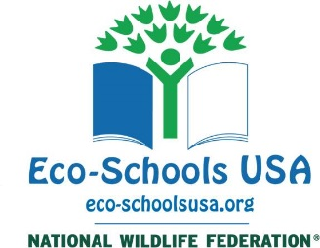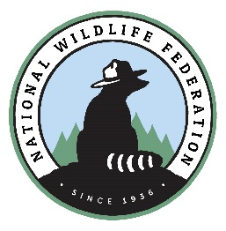

Guilford Elementary School Awarded Eco-Schools USA Green Flag for Exceptional ‘Green’ Achievement

Honor indicates commitment to sustainable curricula and school operations

Reston, VA (June 15, 2018) – Guilford Elementary School was recognized by National Wildlife Federation’s Eco-Schools USA program for exceptional achievement in ‘greening’ physical structure and grounds, conserving natural resources and integrating environmental education into curricula. It is the 6th school so honored in Maryland, and the 108th to win the Green Flag, Eco-Schools USA’s highest honor.

The Eco-Schools USA program, which is based on the work of student-driven teams dedicated to issues like recycling and energy conservation using sample materials, background information and teacher advice provided by NWF, claims more than 4,300 American schools across 49 states so far.

“We at National Wildlife Federation and Eco-Schools USA are proud of the example set by Guilford Elementary School for Maryland, other schools, and the country at large,” said Kim Martinez, Senior Director of Eco-Schools USA. “This award demonstrates not only a commitment to sustainability and environmental literacy for students and faculty, but an appreciation that the best, most effective education transcends the classroom and offers a hands-on approach to learning”

To win the Green Flag, Guilford Elementary School’s students and faculty tackled a host of sustainability initiatives that began with forming an Eco-Action team; auditing facility energy efficiency, waste disposal and other environmental impact areas; and instituting environmental-themed curricula. These steps led to a certified Monarch Way Station, recycling monitors, sorting stations in the lunchroom, no –idling zone, beautification projects, energy and water conservation movies and signs, storm drain painting, recess walking, and many other projects all designed to raise environmental and natural awareness, cut waste, increase student engagement and save money for the school.

National Wildlife Federation was named the stateside host for the international Eco-Schools program in 2008. The original Eco-Schools (http://www.eco-schools.org/) program is an international network of 50,000 K-12 schools in 62 nations, started in 1994 by the Foundation for Environmental Education (FEE) with support by the European Commission. It was named by the United Nations Environment Program (UNEP) as a model initiative for Education for Sustainable Development in 2003. To learn more about Eco-Schools USA, visit www.eco-schoolsusa.org.

Inspiring Americans to protect wildlife for our children's future.

